Homework 1

Draw a ROC curve.

I use python to draw this curve with two methods:

1. Use the definition of ROC curve.

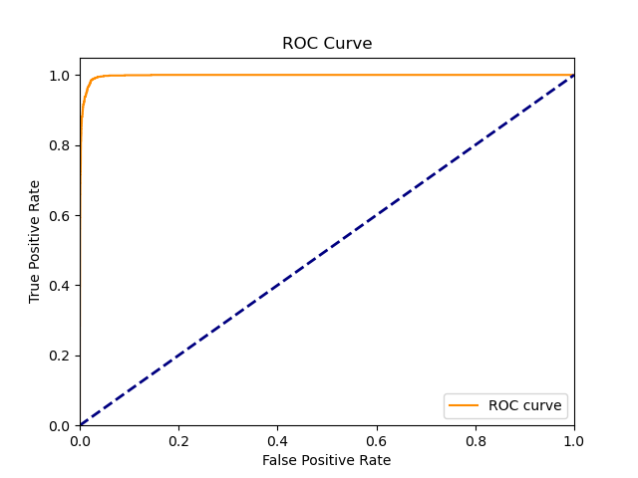

1. Use the python lib about ROC curve.

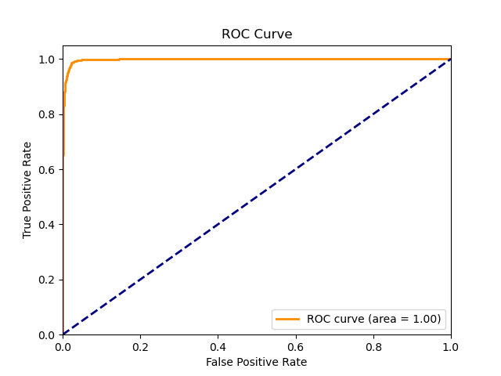

The data I get is from a CNN model I have written. The curve shows that my model may be good in some situation.

Codes:

|  |
| --- |
| import numpy as np  import matplotlib.pyplot as plt  import math  from sklearn.metrics import roc_curve, auc  path = r'.\MachineLearning\homework1'  filename = path + r'\result.txt'  with open(filename, 'r') as file:      lines = file.readlines()  class Data:      def __init__(self, number, state):          self.number = number          self.state = state      def __lt__(self, other):          return self.number > other.number  arr = []  for line in lines:      number = line.strip().split()      rate = float(number[0])      if number[1] == 'True':          y = 1      else:          y = 0      arr.append(Data(rate, y))  arr = np.array(arr)  def sigmoid(x):      return 1 / (1 + np.exp(-x))  arr = np.array([Data(sigmoid(x.number), x.state) for x in arr])  arr = sorted(arr)  y_true = [x.state for x in arr]  y_score = [x.number for x in arr]  def DrawUseLib():      fpr, tpr, thresholds = roc_curve(y_true, y_score)      roc_auc = auc(fpr, tpr)      plt.figure()      plt.plot(fpr, tpr, color='darkorange', lw=2, label=f'ROC curve (area = {roc_auc:.2f})')      plt.plot([0, 1], [0, 1], color='navy', lw=2, linestyle='--')      plt.xlim([0.0, 1.0])      plt.ylim([0.0, 1.05])      plt.xlabel('False Positive Rate')      plt.ylabel('True Positive Rate')      plt.title('ROC Curve')      plt.legend(loc='lower right')      plt.savefig(path + r'\res_2.png')      plt.show()  def DrawUseDefinition():      nowx, nowy, tot = 0, 0, 0      for i in range(len(arr)):          if y_true[i] == 1:              tot += 1      x = []      y = []      for i in range(len(arr)):          if y_true[i] == 1:              nowy += 1.0 / tot          else:              nowx += 1.0 / (len(arr) - tot)          x.append(nowx)          y.append(nowy)      plt.figure()      plt.plot(x, y, color='darkorange', label='ROC curve')      plt.plot([0, 1], [0, 1], color='navy', lw=2, linestyle='--')      plt.xlim([0.0, 1.0])      plt.ylim([0.0, 1.05])      plt.xlabel('False Positive Rate')      plt.ylabel('True Positive Rate')      plt.title('ROC Curve')      plt.legend(loc='lower right')      plt.savefig(path + r"\res_1.png")      plt.show() |